

SUPPORTING PUPILS WITH MEDICAL CONDITIONS
POLICY & PROCEDURES
Version: May 2026

Responsible Management Committee (MC) | Curriculum, Attendance and Wellbeing
Date last approved by MC | March 2025
Responsible Person | SENDco
To Review Date | May 2027
Last Amended Date | May 2026

Contents
- Rationale
- Aims
- Roles and responsibilities
- Equal opportunities
- Managing medicines
- Administering medication procedures
- Individual health care plans
- Parent/carer Medical Agreement form
- Storage of medicines at HPRS
- Procedure for administering medicine
- Procedure for medicine off-site
- Training
- Emergency procedures
- Unacceptable practice
- Complaints
- Appendix 1-5
- Further advice and resources

Rationale

At Herefordshire Pupil Referral Service (HPRS) we ensure that pupils with medical conditions receive appropriate care and support at school. Most pupils will at some time have a medical condition that may affect their participation in school activities. To minimise disruption to their learning we are committed to support pupils with the administering of medication, be it for a short term illness or for a long term condition. We are committed to meeting the needs of all pupils with Special Educational Needs and Disabilities and this includes children with medical conditions. This document will outline the procedures in place when administering medication. This procedure is written in accordance with the most recent statutory guidance: ‘Supporting pupils at school with medical conditions 2014’ (updated August 2017)

Please Note:
No child will be given any prescription or non-prescription medicines without parental consent except in exceptional circumstances.

Medicines MUST be in date, labelled, and provided in the original container
(except in the case of insulin which may come in a pen or pump) with dosage.

Medicines which do not meet these criteria will not be administered.

Aims

This policy aims to ensure that:
- Pupils, staff and parents understand how our service will support pupils with medical conditions.
- Pupils with medical conditions are properly supported to allow them to access the same education as other pupils, including service trips and sporting activities.
The named person with responsibility for implementing this policy is;
- Bev Blower (Head of Service), April Howard (SENDCo) – St David’s.
- Sarah Mobbs (Interim Head of Centre) – The Aconbury centre.
- Jenny Rooney (Assistant Headteacher), Jon Sheers (Assistant Headteacher) – H3.
- Nick James-Williams (Deputy Head of Service) – The Harvest Project.
Roles and responsibilities
The Management Committee is responsible for:
- Ensuring that this Policy, as written, does not discriminate on any grounds including, but not limited to: ethnicity/national origin, culture, religion, gender, disability, sexual orientation or health.
- Handling complaints regarding this policy as outlined in the school’s Complaints Policy.
- Ensuring that all pupils with medical conditions can participate fully in all aspects of school life.
- Ensuring that the school’s policy is explicit about what practice is not acceptable.
The Management Committee has ultimate responsibility to make arrangements to support pupils with medical conditions. The Management Committee will ensure that sufficient staff have received suitable training and are competent before they are responsible for supporting children with medical conditions.
The Head of Centre is responsible for:
- Making sure all staff are aware of this policy and understand their role in its implementation.
- Ensuring that there is a sufficient number of trained staff available to implement this policy and deliver against all individual healthcare plans (IHPs), including in contingency and emergency situations.
- Ensuring that all staff who need to know are aware of a child’s condition.
- Take overall responsibility for the development of IHPs.
- Making sure that school staff are appropriately insured and aware that they are insured to support pupils in this way.
- Contacting the school nursing service in the case of any pupil who has a medical condition that may require support at school, but who has not yet been brought to the attention of the school nurse.
- Ensuring that systems are in place for obtaining information about a child’s medical needs and that this information is kept up to date.
Staff are responsible for:
Supporting pupils with medical conditions during school hours is not the sole responsibility of one person. Any member of staff may be asked to provide support to pupils with medical conditions, although they will not be required to do so. This includes the administration of medicines.
Those staff who take on the responsibility to support pupils with medical conditions will receive sufficient and suitable training and will achieve the necessary level of competency before doing so.
Teachers will take into account the needs of pupils with medical conditions that they teach. All staff will know what to do and respond accordingly when they become aware that a pupil with a medical condition needs help.

Parents are responsible for:
- Keeping the school informed about any changes to their child/children’s health including any new diagnoses.
- Completing a parental agreement for school to administer medicine form before bringing medication into school.
- Providing the school with the medication their child requires and keeping it up to date. All medicine MUST clearly show the child’s name, DOB, medicine name, dosage and expiry date.
- Collecting any leftover medicine at the end of the course or year.
- Discussing medications with their child/children prior to requesting that a staff member administers the medication.
- Where necessary, developing an Individual Healthcare Plan (IHCP) for their child in collaboration with the Head of Centre, other staff members and healthcare professionals.
- Carry out any action they have agreed to as part of the implementation of the IHP, e.g. provide medicines and equipment, and ensure they or another nominated adult are contactable at all times.
Pupils are responsible for:
Pupils with medical conditions will often be best placed to provide information about how their condition affects them. Pupils should be fully involved in discussions about their medical support needs and contribute as much as possible to the development of their IHPs. They are also expected to comply with their IHPs.
School nurses and other healthcare professionals
Our school nursing service will notify the school when a pupil has been identified as having a medical condition that will require support in school. This will be before the pupil starts school, wherever possible. They may also support staff to implement a child’s IHP.
Healthcare professionals, such as GPs and paediatricians, will liaise with the school’s nurses and notify them of any pupils identified as having a medical condition. They may also provide advice on developing IHPs.

Equal opportunities

HPRS is clear about the need to actively support pupils with medical conditions to participate in service trips and visits, or in sporting activities, and not prevent them from doing so.
HPRS will consider what reasonable adjustments need to be made to enable these pupils to participate fully and safely on service trips, visits and sporting activities.
Risk assessments will be carried out so that planning arrangements take account of any steps needed to ensure that pupils with medical conditions are included. In doing so, pupils, their parents and any relevant healthcare professionals will be consulted.

Managing medicines
Prescription medicines will only be administered at HPRS:
- When it would be detrimental to the pupil’s health or service attendance not to do so and
- Where we have parents’ written consent.
The only exception to this is where the medicine has been prescribed to the pupil without the knowledge of the parents.
Pupils under 16 will not be given medicine containing aspirin unless prescribed by a doctor.
Anyone giving a pupil any medication (for example, for pain relief) will first check maximum dosages and when the previous dosage was taken. Parents will always be informed.
HPRS will only accept prescribed medicines that are:
- In-date.
- Labelled.
- Provided in the original container, as dispensed by the pharmacist, and include instructions for administration, dosage and storage.
HPRS will accept insulin that is inside an insulin pen or pump rather than its original container, but it must be in date.
All medicines will be stored safely. Pupils will be informed about where their medicines are at all times and be able to access them immediately. Medicines and devices such as asthma inhalers, blood glucose testing meters and adrenaline pens will always be readily available to pupils and not locked away.
Medicines will be returned to parents to arrange for safe disposal when no longer required.

ADMINISTERING MEDICATION PROCEDURES

Being notified that a child has a medical condition
When HPRS is notified that a pupil has a medical condition, the process outlined below will be followed to decide whether the pupil requires an IHP.
HPRS will make every effort to ensure that arrangements are put into place within 2 weeks, or by the beginning of the relevant term for pupils who are new to our service.

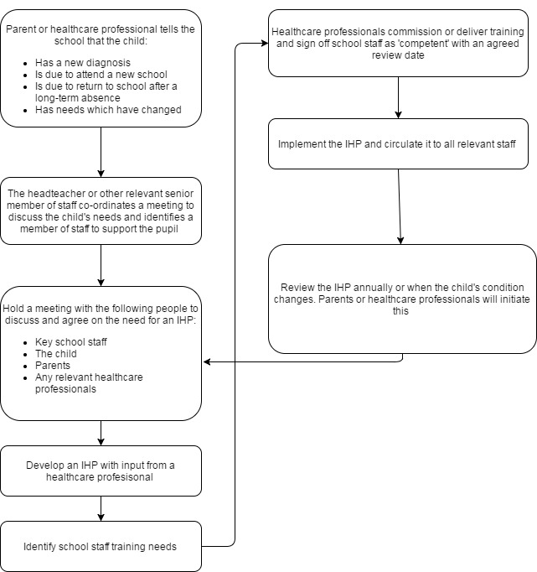
Individual Health Care Plans

All pupils on admission to HPRS are given a Medical Condition Declaration Form. If a pupil has a medical condition identified this will trigger the completion of an Individual Health Care Plan (IHCP) compiled in conjunction with parents/carers. These are kept in a secure green file and on Arbor (MIS) enabling staff at the appropriate centre to access them if required to obtain medical information; including details of any medication that is needed.

Parent/Carer Medical Agreement Form

All pupils who require any medication whilst at school will have a Parent/Carer Medical Agreement Form that is completed and signed by their parent/carer. These forms will be kept with pupils IHCP in the secure green file at the pupil’s respective centre. These will also be required for short term prescribed medications, such as antibiotics.

Storage of Medicines at HPRS

HPRS will only accept prescribed medicines that are:
- In-date.
- Labelled.
- Provided in the original container, as dispensed by the pharmacist and include instructions for administration, dosage and storage.

HPRS will accept insulin that is inside an insulin pen or pump rather than its original container, but it must be in date.

Medicines will be stored safely in accordance with their instructions.
Medicines and devices such as asthma inhalers, blood glucose testing meters and adrenaline pens will be labelled with the pupil’s name and will always be readily available to pupils and not locked away but kept in the First Aid cupboard.

- At St David’s Centre they are stored in the First Aid cupboard or the safe or locked fridge cabinet.
At The Aconbury Centre they are stored in the First Aid cupboard or a locked cabinet or a locked fridge cabinet.
- At H3 they are stored in a First Aid cupboard or medical cabinet or locked fridge cabinet.

Medicines will be returned to parents to arrange for safe disposal when no longer required.

Procedure for Administering Medicine

- Parents MUST inform HPRS of any medication their child is taking even if it is only taken at home. This is important as we may be in the position of taking a child to hospital as an emergency and be asked about their medication.
- Medicine will only be given by school staff when provided in its original packaging with pharmacy sticker visible.
- Each time medication is given to a pupil it is checked by the member of staff giving it.
It is checked that the medication:
- Is in date.
- Is the correct dose.
It is recorded each time medication is given and countersigned by a second member of staff.
- The school reserves the right to refuse responsibility for the administration of medicine in some instances.
- Children who are acutely ill and who require a short course of medication e.g. antibiotics, will normally remain at home until the course is finished.
- Products containing paracetamol can only be administered by school after telephoning parents/carers to ensure no other product containing paracetamol has been given or may have been given in the home environment to prevent overdose.
- Any changes to medication must be reported to school.

Procedure for Medicine Off-site

If a pupil is taken offsite the member/s of staff that they are with should sign out all medication that they will require for the full period of absence from the centre using the hardback book.

The same procedures should be followed as when in the centre. It is essential that any staff taking care of pupils when offsite have read and understood pupils IHCPs and have a copy of the Parent/Carer Medical Agreement Form with them before taking the pupil offsite. They should have a log book to record when medication is taken. Details should then be recorded in the hardback book upon their return.

Training

Staff who are responsible for supporting pupils with medical needs will receive suitable and sufficient training to do so.
The training will be identified during the development or review of IHPs. Staff who provide support to pupils with medical conditions will be included in meetings where this is discussed.
The relevant healthcare professionals will lead on identifying the type and level of training required and will agree this with the head of centre. Training will be kept up to date.
Training will:
- Be sufficient to ensure that staff are competent and have confidence in their ability to support the pupils.
- Fulfil the requirements in the IHPs.
- Help staff to have an understanding of the specific medical conditions they are being asked to deal with, their implications and preventative measures.
Healthcare professionals will provide confirmation of the proficiency of staff in a medical procedure, or in providing medication.
All staff will receive training so that they are aware of this policy and understand their role in implementing it, for example, with preventative and emergency measures so they can recognise and act quickly when a problem occurs. This will be provided for new staff during their induction.

Emergency Procedures

Staff will follow HPRS’s normal emergency procedures (for example, calling 999). All pupils’ IHCPs will clearly set out what constitutes an emergency and will explain what to do if there are exceptional circumstances. All staff will read these documents.

If a pupil needs to be taken to hospital, staff will stay with the pupil until the parent arrives, or accompany the pupil to hospital by ambulance.

Unacceptable Practice
Although school staff should use their discretion and judge each case on its merits with reference to the child’s individual healthcare plan, it is not generally acceptable practice to:
• Prevent children from easily accessing their inhalers and medication and administering their medication when and where necessary.
• Assume that every child with the same condition requires the same treatment.
• Ignore the views of the child or their parents; or ignore medical evidence or opinion (although this may be challenged).
• Send children with medical conditions home frequently for reasons associated with their medical condition or prevent them from staying for normal school activities, including lunch, unless this is specified in their individual healthcare plans.
• If the child becomes ill, send them to the school office or medical room unaccompanied or with someone unsuitable.
• Penalise children for their attendance record if their absences are related to their medical condition, e.g. hospital appointments.
• Prevent pupils from drinking, eating or taking toilet or other breaks whenever they need to in order to manage their medical condition effectively.
• Require parents, or otherwise make them feel obliged, to attend school to administer medication or provide medical support to their child, including with toileting issues. No parent should have to give up working because the school is failing to support their child’s medical needs; or prevent children from participating, or create unnecessary barriers to children participating in any aspect of school life, including school trips, e.g. by requiring parents to accompany the child.

Complaints
Parents with a complaint about the school’s actions in regard to their child’s medical condition should discuss these directly with the headteacher/ head of centre in the first instance. If the headteacher/ head of centre cannot resolve the matter, they will direct parents to the school’s complaints procedure.

APPENDIX 1: IHCP TEMPLATE

PUPIL INFORMATION
PUPIL FULL NAME
DOB
ADDRESS
MEDICAL CONDITION
DATE OF PLAN
REVIEW DATE

FAMILY CONTACT INFORMATION
 | CONTACT 1 | CONTACT 2
FULL NAME
MOBILE NUMBER
HOME NUMBER
WORK NUMBER
RELATIONSHIP TO CHILD

HOSPITAL / DOCTOR INFORMATION
 | CLINICIAN | GP
NAME
PHONE NUMBER

WHO IS RESPONSIBLE FOR PROVIDING SUPPORT TO HPRS
NAME
PHONE NUMBER
MEDICAL NEEDS
Describe medical needs and give details of child’s symptoms, triggers, signs, treatments, facilities, equipment or devices, environmental issues etc.
SYMPTOMS / SIGNS

TRIGGERS

TREATMENTS

WHAT CONSTITUTES AN EMERGENCY

MEDICATION
NAME
DOSAGE
HOW ADMINISTERED
WHEN TO TAKE
SIDE EFFECTS
ADMINISTERED BY SELF / NAME OTHER

DAILY CARE REQUIREMENTS
SPECIFIC SUPPORT REQUIRED
SPECIAL ARRANGEMENTS FOR TRIPS
ANY OTHER RELEVANT INFORMATION

PLAN WRITTEN BY
PLAN WRITTEN WITH
STAFF TRAINING REQUIRED
STAFF TRAINED (NAME AND DATE)

APPENDIX 2: PARENT/CARER MEDICAL AGREEMENT FORM

HPRS will not be able to give your child medicine unless you complete and sign this form.
PUPIL FULL NAME
DOB
MEDICAL CONDITION
REVIEW DATE

MEDICATION
NAME AS PRINTED ON THE PACKET
EXPIRY DATE
DOSAGE & METHOD
TIME
SIDE EFFECTS?
SELF ADMINISTERED Y/N
PROCEDURES TO TAKE IN AN EMERGENCY?
NB: Medicines must be in the original container as dispensed by the pharmacy
CONTACT DETAILS
 | CONTACT 1 | CONTACT 2
FULL NAME
MOBILE NUMBER
HOME NUMBER
WORK NUMBER
RELATIONSHIP TO CHILD
I UNDERSTAND I MUST DELIVER THE MEDICINE IN PERSON TO

The above information is, to the best of my knowledge, accurate at the time of writing and I give consent to HPRS staff administering medicine in accordance with the HPRS policy. I will inform HPRS immediately, in writing, if there is any change in dosage or frequency of the medication or if the medicine is stopped.
SIGNED: DATE:

APPENDIX 3: RECORD OF MEDICINE ADMINISTERED FORM

PUPIL FULL NAME
DATE MEDICINE PROVIDED BY PARENT
QTY RECEIVED
NAME AS PRINTED ON THE PACKET
EXPIRY DATE
DOSAGE & METHOD
TIME

DATE
TIME GIVEN
DOSAGE GIVEN
STAFF NAME

DATE
TIME GIVEN
DOSAGE GIVEN
STAFF NAME

DATE
TIME GIVEN
DOSAGE GIVEN
STAFF NAME

APPENDIX 4: MODEL LETTER INVITING TO IHP MEETING

RE: DEVELOPING AN INDIVIDUAL HEALTHCARE PLAN FOR YOUR CHILD

Dear Parent,
Thank you for informing us of your child’s medical condition. I enclose a copy of the school’s policy for supporting pupils at school with medical conditions for your information.
A central requirement of the policy is for an individual healthcare plan to be prepared, setting out what support each pupil needs and how this will be provided. Individual healthcare plans are developed in partnership with HPRS, parents/carers, pupils, and the relevant healthcare professional who can advise on your child’s case. The aim is to ensure that we know how to support your child effectively and to provide clarity about what needs to be done, when and by whom. Although individual healthcare plans are likely to be helpful in the majority of cases, it is possible that not all children will require one. We will need to make judgements about how your child’s medical condition impacts their ability to participate fully in school life, and the level of detail within plans will depend on the complexity of their condition and the degree of support needed.
A meeting to start the process of developing your child’s individual health care plan has been scheduled for xx/xx/xx. I hope that this is convenient for you and would be grateful if you could confirm whether you are able to attend. The meeting will include add details of team. Please let us know if you would like us to invite another medical practitioner, healthcare professional or specialist and provide any other evidence you would like us to consider at the meeting as soon as possible.
If you are unable to attend, it would be helpful if you could complete the attached individual healthcare plan template and return it, together with any relevant evidence, for consideration at the meeting. I or add name of other staff lead would be happy for you contact me [them] by email or to speak by phone if this would be helpful.

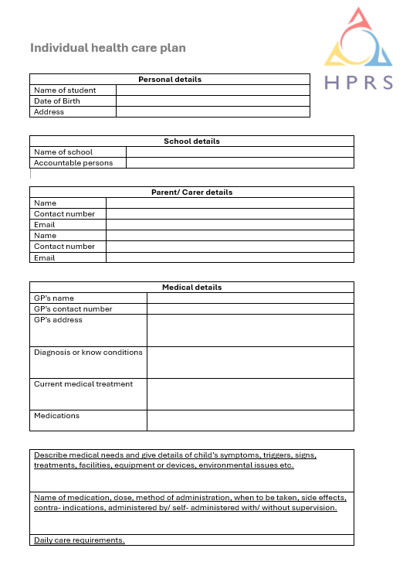
APPENDIX 5: IHCP TEMPLATE 2

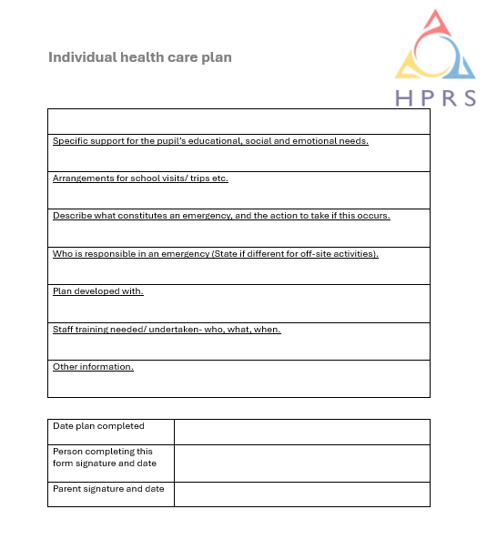

Further advice and resources

The Anaphylaxis Campaign  Phone 01252 546100  info@anaphylaxis.org.uk  www.anaphylaxis.org.uk | Asthma + Lung UK  Phone 0300 222 5800  helpline@asthmaandlung.org.uk  www.asthmaandlung.org.uk | Diabetes UK  Phone 020 7424 1001  helpline@diabetes.org.uk  www.diabetes.org.uk
Epilepsy Action  Phone 0113 210 8800  epilepsy@epilepsy.org.uk  www.epilepsy.org.uk | National Children’s Bureau  Phone 020 7843 6000  enquiries@ncb.org.uk  www.ncb.org.uk

